PSSI Science Project Reporting Template

️ | The PSSI Implementation Team is compiling a technical report to demonstrate the important research and advancements made by the Science Branch through the PSSI funding. The technical report will include a 3-4 page summary (including graphics and figures) for each project to show their key results and findings. Please fill in the following fields and sections for your project to be included in the report. Feel free to include and draw from any reports or presentations previously created through your research.  A plain language science bulletin will also be created to follow up on last year’s “DFO Pacific Region Science Bulletin, 2024. New research and monitoring for Pacific salmon and their ecosystems.” While the first bulletin introduced project backgrounds, methods, and timelines, this new bulletin will highlight the projects’ results, key findings, and conclusions with links to reports and data available. The bulletin will include a 1-2 page summary for each project gleaned from the content entered below.  ️ Completed forms are due January 7, 2026.  *Please include or send separately any graphics or pictures (with photo credits) that will help promote the projects.

PART 1: PROJECT METADATA

General Project Information
Project ID (number) | Project Title
2401 | Epidemiological modeling of infectious hematopoietic necrosis virus in Sockeye salmon
Project Leads | Collaborations and External Partners
Kyle Garver | Click or tap here to enter text.
Location (if applicable) | Click or tap here to enter text.
Click or tap here to enter text. | Click or tap here to enter text.

Geographic and Stock Information
Salmon species (if applicable) | Waterbodies (if applicable)
Sockeye salmon | Weaver Creek, Nadina River, Fulton River, Pinkut Creek
Life history phases (if applicable) | Region
Click or tap here to enter text. | Click or tap here to enter text.
Stock (if applicable) | Population (if applicable)
Click or tap here to enter text. | Click or tap here to enter text.
Conservation Unit (if applicable)
Click or tap here to enter text.

🧰 PART 2: PROJECT METRICS

Project Outputs
Include any anticipated outputs denoted as (in progress). Please include links to any outputs available online so they can be referenced in the report.
List scientific publications and technical reports (with links)
https://waves-vagues.dfo-mpo.gc.ca/library-bibliotheque/41053539.pdf

Peer-reviewed journal publication (in progress)
List datasets generated (with links)
Long-term IHNV prevalence dataset to be made publicly available through peer-reviewed publication (in progress)
Describe dataset locations and data management systems
Click or tap here to enter text.
List code, programs, or other software created (with links)
Statistical code to be made publicly available through peer-reviewed publication (in progress)
List communication or social media products
Click or tap here to enter text.
List and describe field work completed
Click or tap here to enter text.
List and describe samples collected/analyzed (number of samples)
32 years of collection: 1987-2018
Total sockeye salmon specimens collected and tested: 56,692 (35,504 fry + 21,188 Adults)
List and describe large capital assets or equipment acquired
Click or tap here to enter text.

PART 3: WRITTEN CONTENT

Highlights
Please summarize in 2-3 bullets:
- The main idea of the project
- Key findings
- Implications of these findings for salmon and decision-makers
- For a more technical audience, but still as plain language as possible
This study examined IHNV prevalence across different watersheds, Sockeye stocks, and environmental conditions to identify those factors responsible for driving IHNV prevalence and/or influencing disease within Sockeye salmon populations.

Background
Please provide 1-2 paragraphs to summarize
- The relevant biological, environmental, and/or management context
- What knowledge gap or demand were you trying to fill?
- Collaboration and partner relationships
Infectious hematopoietic necrosis virus (IHNV) is a deadly virus of Sockeye salmon, causing catastrophic losses during the early lifestages. Long-term monitoring of IHNV infections across multiple stocks of Sockeye salmon has revealed the prevalence of IHNV infections can vary annually within and between stocks; however, the factor(s) responsible for such fluctuations in IHNV prevalence in sockeye salmon stocks in British Columbia remain unresolved. Understanding the drivers behind the occurrence and perpetuation of IHNV in Sockeye salmon is instrumental in managing and mitigating the risk of this endemic pathogen. Utilizing epidemiological analytical approaches to study the patterns of IHNV in Sockeye salmon we’ll identify the factors which influence the prevalence of the virus in BC Sockeye salmon stocks.

️ Methods and Findings
Please insert a few paragraphs to summarize:
- Main methods used
- Products and tools produced
- Advancements in methodology, technology, and application
- Advancements in communication and knowledge transfer
- Key results and information generated
METHODS:
Adult and fry Sockeye salmon were each collected annually from 1987 to 2018, from each of four spawning channel populations, representing two stocks within the Fraser River watershed and two within the Skeena River watershed (Figure 1). Samples were screened for the presence of infectious hematopoiectic necrosis virus (IHNV) using cell culture methodologies. Characteristic cytopathic effects (CPE) observed in cells indicated the presence of viable replicating IHNV. Prevalence of IHNV was calculated by dividing the number of samples with CPE by the total number of samples screened.

We used statistical methods to understand how IHNV prevalence in adult fish relate to infection levels in fry, and how infection in fry affects infection in adults that return 3–4 years later.

To compare how infection levels changed over time, we looked at time-series data for each project site (Fulton, Pinkut, Nadina, Weaver) and for each life stage (fry, adult males, adult females). We used a clustering method that can line up patterns even when the timing doesn’t match perfectly (a technique called dynamic time warping) to measure how similar the trends were.

To study how infection in returning adults affects IHNV prevalence in fry, we used a mixed-effects binomial model for proportions that accounted for differences between spawning years and project sites.

To study how fry infection affects infection in adults 3–4 years later, we used a similar model along with escapement data to calculate a weighted average of fry infection that matched the makeup of the returning adult population. Because the relationship wasn’t linear, we also added a quadratic term to better capture the pattern.

RESULTS:
From 1987 to 2018, a total of 56,692 Sockeye salmon were screened for IHNV. Over this 32 year timeframe, the prevalence of IHNV infections varied annually within and between the four stocks sampled (Figure 2). Across the entire dataset, there was a positive correlation between the detection of IHNV in male and female samples; with the prevalence being generally higher in females than in males (Figure 3). Nonetheless, this prevalence in spawned females was not demonstrative of what was observed in fry, as there were numerous years where IHNV was not detected in the fry despite high prevalence in the broodstock. However, it appears as though the IHNV prevalence in fry is a strong predictor of the population’s IHNV status upon returning adults 4 years later. For instance, fry with 50% IHNV prevalence are predicted to return as adults with a prevalence of 30 to 80% (Figure 4).

Insights
Please insert a few paragraphs to summarize:
- What this project has added to knowledge about salmon populations, health, or ecosystems.
- How this project informs salmon management:
  - decisions
  - policy guidance
  - trade-offs
  - planning
- Addition of knowledge to understanding:
  - limiting factors/stressors/threats/ pathways of effects/risks
  - biologically significant thresholds
  - cumulative impacts
- Sources of uncertainty
This work provides the first long-term dataset of infectious hematopoietic necrosis virus (IHNV) prevalence among various Sockeye salmon stocks in British Columbia and reveals a highly dynamic nature of this deadly virus. From this data, it was learned that when surveying adult fish, it is best to sample females as they have the highest prevalence. In naturally spawning populations of Sockeye salmon, it was found that the IHNV prevalence in broodstock offers little insight into the infection status of fry, as true parent to progeny transmission is unlikely. In many instances, high IHNV prevalence in adults did not result in the occurrence of virus in fry. However, unexpectedly it was discovered that IHNV prevalence in fry is significantly correlated to the prevalence of returning adults, suggesting IHNV in adults is partially explained by their status as fry and supports the role of a lifelong IHNV carrier state in perpetuating IHNV in Sockeye salmon populations.

⏩ Next Steps
Please insert 1-2 paragraphs to summarize:
- Remaining knowledge gaps and recommendations for future studies
- How can/should the project findings be operationalized for salmon conservation and management?
This work illustrates the importance of long-term datasets in differentiating genuine trends from short term fluctuations and to uncover complex ecological dynamics. Analysis of IHNV prevalence across the four stocks over the 32 year timeframe revealed that prevalence across stocks is most similar within a river system, suggesting watershed or regional specific factors may influence level of IHNV in the system (Figure 5). Nonetheless, a shared prolonged reduction of IHNV observed across both Fraser and Skeena watersheds, suggests broader oceanic factor(s) are contributing to the occurrence of IHNV in Sockeye salmon (Figure 2). Given these trends, we are presently gathering environmental, management and other data to determine if there are correlates that are explanatory for these trends. In particularly, we are employing Pacea, an R package of ecosystem information, to link biological data with environmental variable to generate models and visualizations.

📈 Tables and Figures
Please provide captions and numbering for any tables and figures. Graphics can be copied below or e-mailed separately.
- Include a brief caption with each figure and table in the box below
- Number each table and figure, and include references in the above sections where appropriate.
- 1-3 figures are recommended per project

Figure 1. Map showing the locations of the Sockeye Salmon spawning channels (red circles) within the Skeena and Fraser River watersheds, revealed by blue and olive shading; respectively.
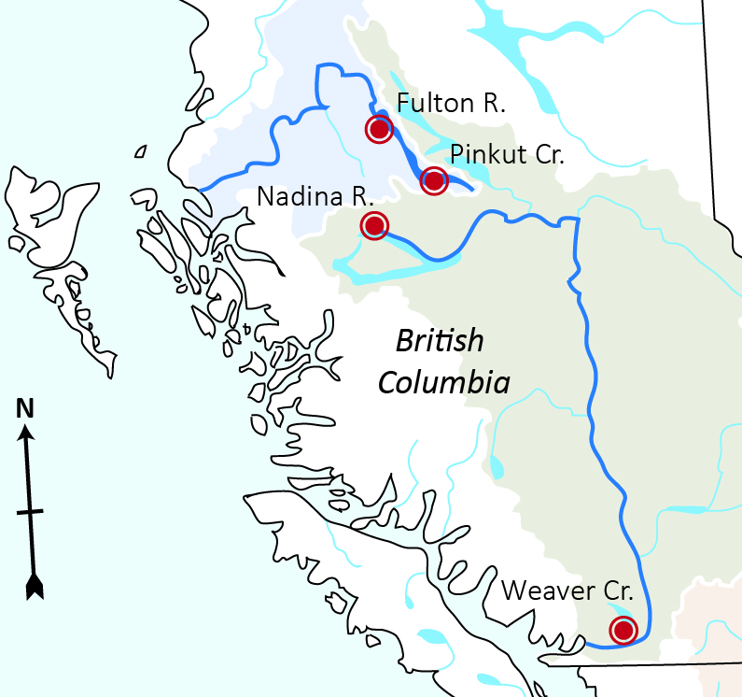

Figure 2. Annual prevalence of IHNV in adults (grey) and fry (black) Sockeye salmon collected over 32 years from spawning channels located at Fulton River, Pinkut Creek, Nadina River and Weaver Creek. Blue shading highlights years where IHNV prevalence was generally lower across all four collection sites.

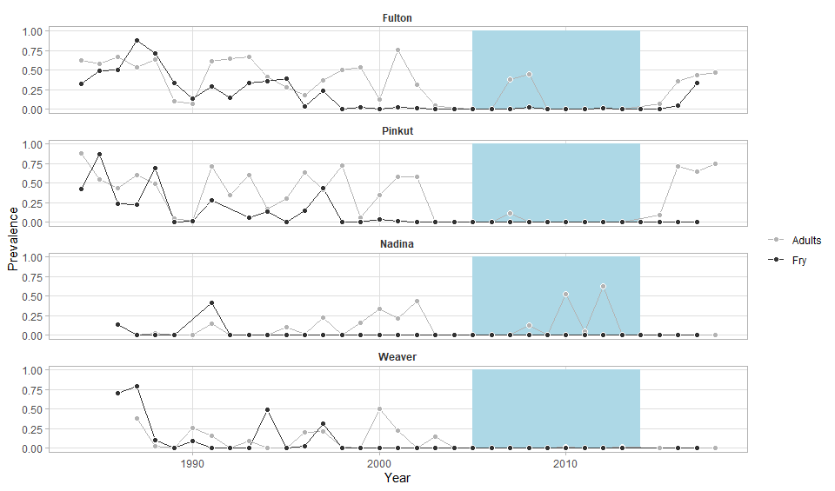

Figure 3. Plot illustrating a positive relationship between IHNV prevalence in males (y-axis) and females (x-axis)

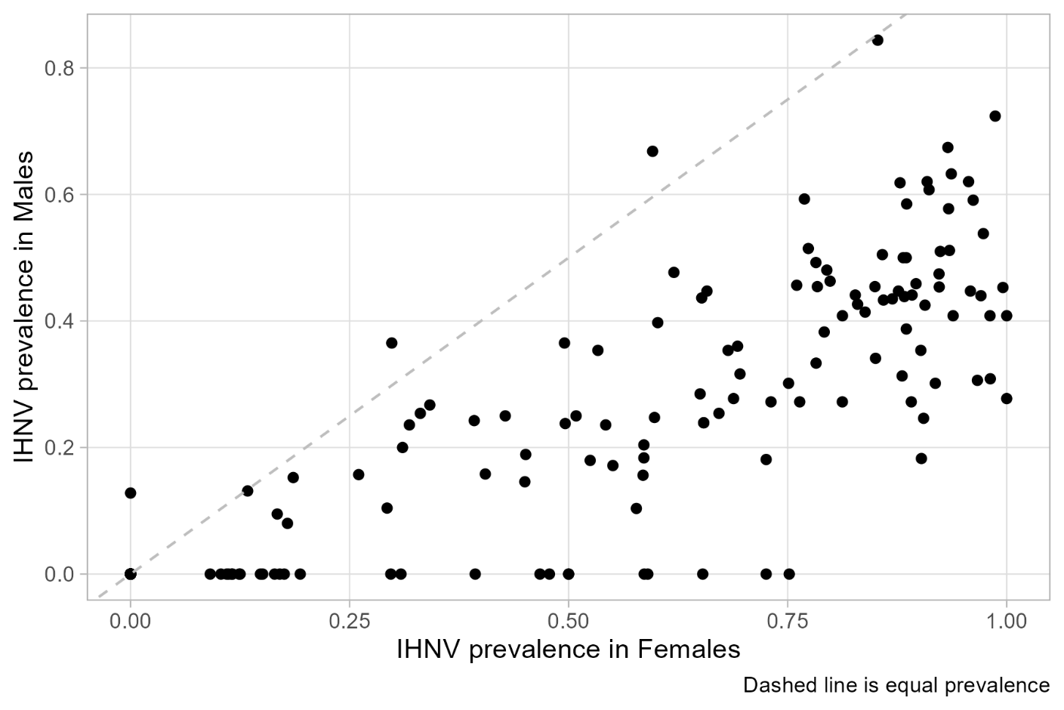

Figure 4. Plot illustrating the predicted IHNV prevalence in returning adult Sockeye salmon to Fulton River Spawning Channel based on IHNV prevalence in fry. Grey shading represents 95% confidence intervals.

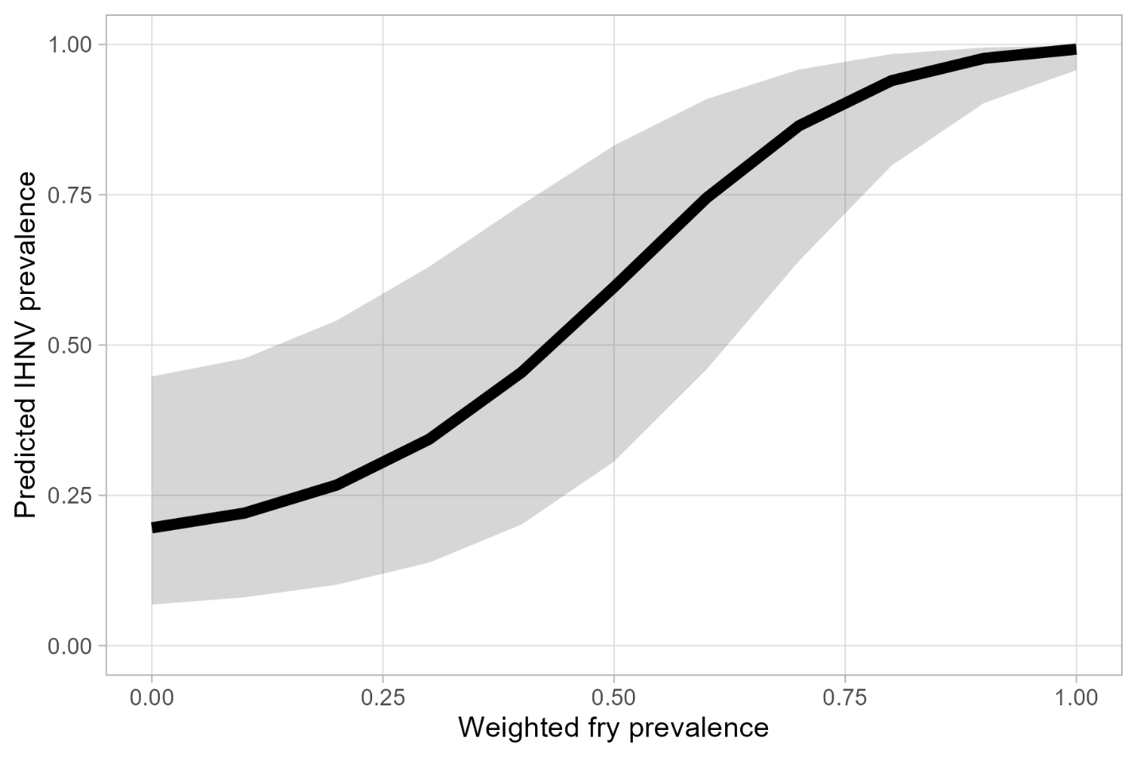

Figure 5. Cluster diagram illustrating similarities in IHNV prevalence of adult female Sockeye salmon across spawning channels over a 32 year time period.

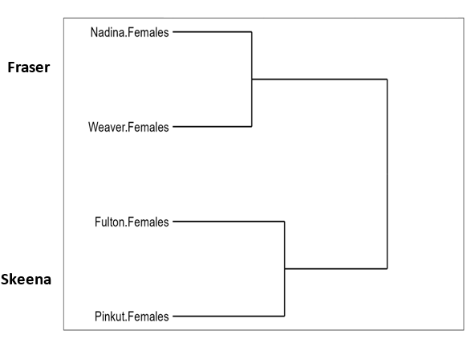

📈 References
Include full references for any publications referenced in other sections. Please format references in Harvard style according to Instructions to Authors for the Canadian Journal of Fisheries and Aquatic Sciences, at Canadian Science Publishing.
Click or tap here to enter text.

